Gazi University DG khan
....Assignment....
Subject: programming fundamental
∆.... Lab 2....∆
Professor: Mr. Asad Majeed
Student name : Maheen Fatima
Class: B.S C.S (1st semester)
Roll number: 13
Submit date:09 Oct 2026
LAB#2
Bonus task...
01.
#include <iostream>
using namespace std;
int main() {
int num;
cout << "Enter a five-digit integer: ";
cin >> num;
cout << num / 10000 << " 8 ";
cout << (num / 1000) % 10 << " 9 ";
cout << (num / 100) % 10 << " 4 ";
cout << (num / 10) % 10 << " 7 ";
cout << num % 10
return 0;
}
Output:
Enter a five-digit integer: 45678
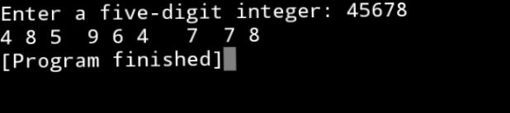
4 8 5 9 6 4 7 7 8

TASK#1:
Type and save the following program in visual studio. Run these Program and observe their output.
1.#include<iostream>
Using namespace std;
Int main(){
Char letter;
Letter = ‘A’;
Cout<<letter<<”\n”;
Letter = ‘A’;
Cout<<letter<<”\n”;
Cin>>letter;
return 0;
}
Output:
A
A
A
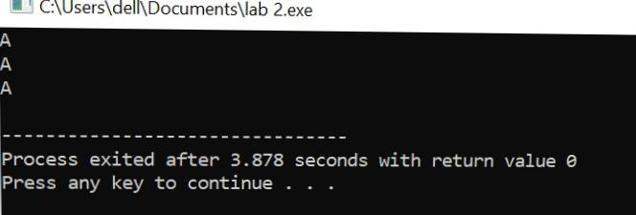
2.#include<iostream
Using namespace std;
Int main(){
Char letter;
Letter = 65;
Cout<<letter<<’\n’;
Letter = 66;
Cout<<letter<<’\n’;
Cin>>letter;
return 0;
}
OutPut:
A
B
C
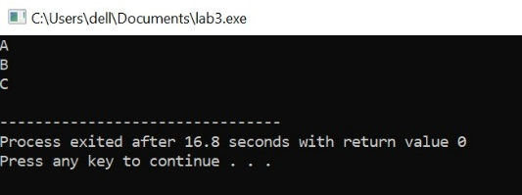
3. #include<iostream>
Using namespace std;
Int main(){
Int letter;
letter = ‘A’;
cout<<letter<<’\n’;
Letter = ‘B’;
Cout<<letter<<’\n’;
Cin>>letter;
return 0;
}
Output:
65
66
67
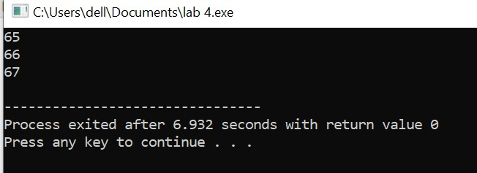
TASK #2:
Take two integers as input from users apply arithmetic operation on Them (+,-,*,/,%) as print them on screen.
#include <iostream>
namespace std;
int main() {
using int a, b;
cout << "Enter first integer: ";
cin >> a;
cout << "Enter second integer: ";
cin >> b;
cout << "\nResults:\n";
cout << a << " + " << b << " = " << a + b << endl;
cout << a << " - " << b << " = " << a - b << endl;
cout << a << " * " << b << " = " << a * b << endl;
if (b != 0) {
cout << a << " / " << b << " = " << a / b << endl;
cout << a << " % " << b << " = " << a % b << endl;
} else {
cout << "Division and modulus by zero are not possible." << endl;
}
return 0;
}
Output...
Enter first integer: 2
Enter second integer: 5
Results:
2 + 5 = 7
2 - 5 = -3
2 * 5 = 10
2 / 5 = 0
2 % 5 = 2
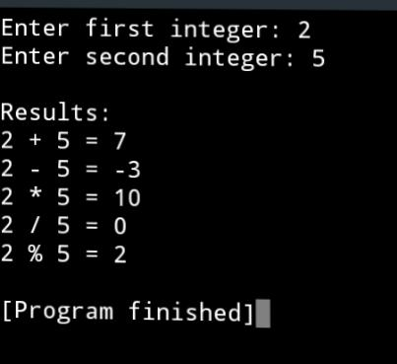
Task #03
Write the output of the following code:
#include<iostream>
using namespace std;
int Main(){
int val1,val2,val3;
cout<< “Please Enter your 3 numbers:”;
Cin>>val1>>val2>>val3;
Cout<<val1<< “\n”<<val2<< “\n”<<val3<< “\n”;
Cout<<val3<< “\n”<<val2<< “\n”<<val1<< “\n”;
System(“PAUSE”);
return 0;
}
Output:
Please enter your 3 numbers: 123
456
789
123
456
789
789
456
123
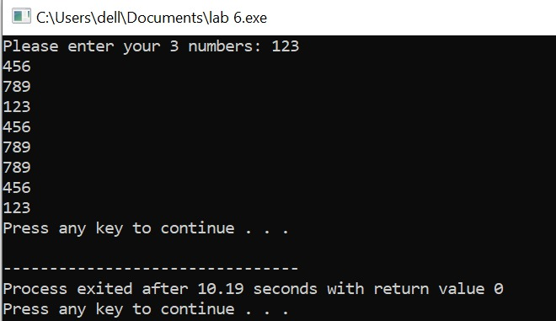
TASK4:
Write c++ program to calculate the distance between the two Points.
NOTE:x1,y1,x2,y2 are all double values.
Formula:
D=(x2-x1)2 +(y2-y1)2
#include<iostream>
Using namespace std;
Int main(){
int X1,y1,x2,y2,d;
cout<< “Enter the value of x1:”;
cin>>x1;
cout<< “enter the value of y1:”;
cin>>y1;
cout<< “enter the value of x2:”;
cin>>x2;
cout<< “enter the value of y2:”;
cin>>y2;
double D=(x2-x1)*(x2-x1)+(y2-y1)*(y2-y1);
cout<< “the distance between two point is:”<<d<<endl;
Return 0;
}
Output:
Enter the value of x1: 2
enter the Value of y1: 4
enter the value of x2: 6
Enter the value of y2: 8
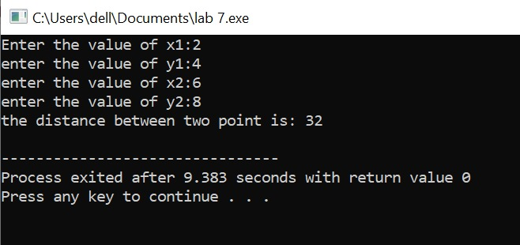
The distance between two point is: 32

Task #05

1.calculate the area of circle(area=pi*r2)
2.calculate the area of a rectangle(area=length*width)
3.calculate the area of triangle(area=base*height*.5)
#include<iostream>
Using namespace std;
Int main(){
//calculate the area of circle
Float pi=3.141592;
Float r,a;
Cout<<”enter the value of radius of a circle: “;
Cin>>r;
A=pi*(r*r);
Cout<<”Area of circle is: “<<a<<endl;
//calculate the area of rectangle float b,l,w;
Cout<<”enter the value of length of rectangle: “;
Cin>>l;
Cout<<”enter the value of width pf rectengel: “;
Cin>>w;
B=l*w;
Cout<<”the area of rectangle is “<<a<<endl;
//calculate the area of a triangle float area , base, height;
Cout<<”enter the value of base of a triangle: “;
Cin>>base;
Cout<<”enter the value of height of a triangle: “;
Cin>>height;
Area=base*height*.5;
Cout<<”the area of triangle is: “<<area<<endl;
Return 0;
}
Output:
Enter the value of radius of a circle:3.4
Area of a circle is:36.3168
Enter the value of length of rectangle:6.5
Enter the value of width of rectangle:7
The area of rectangle is 36.3168
Enter the value of base of a triangle: 5
Enter the value of height of a triangle: 8
The area of triangle is:20
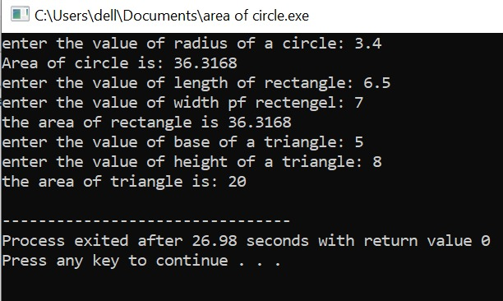
TASK6:
total purchase a customer in a store is purchasing five items. the prices of the five items are:
price of item 1=$12.95.
price of item 2=$24.95.
price of item 3=$6.95.
price of item 4=$14.95.
price of item 5=$3.95.
write a program that holds the prices of the five items in five variables. display each items
prices, the subtotal of the sale, the amount of sales tax, and the total. assume the sales tax is 6%.
#include <iostream>
#include <iomanip>
using namespace std;
int main() {
double item1 = 12.95; double item2 = 24.95;
double item3 = 6.95;
double item4 = 14.95;
double item5 = 3.95;
double subtotal = item1 + item2 + item3 + item4 + item5;
double salesTax = subtotal * 0.06;
double total = subtotal + salesTax;
cout << std::fixed << std::setprecision(2);
cout << "Item 1: $" << item1 << '\n';
cout << "Item 2: $" << item2 << '\n';
cout << "Item 3: $" << item3 << '\n';
cout << "Item 4: $" << item4 << '\n';
cout << "Item 5: $" << item5 << '\n';
cout << "Subtotal: $" << subtotal << '\n';
cout << "Sales tax (6%): $" << salesTax << '\n';
cout << "Total: $" << total << '\n';
return 0;
}
OUTPUT: Item 1: $12.95
Item 2: $24.95
Item 3: $6.95
Item 4: $14.95
Item 5: $3.95
Subtotal: $63.75
Sale tax (6%): $3.82
Total: $67.58
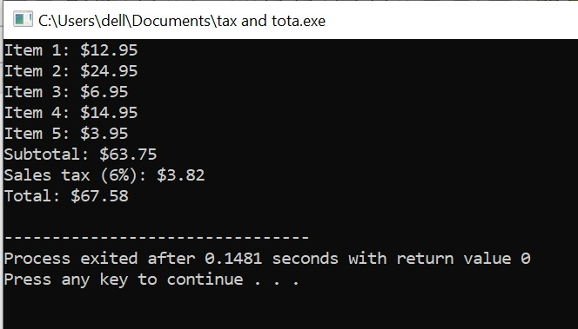
HOME TASK1:
Write a program that read in two variable and swaps the value
of these variable.
#include<iostream>
using namespace std;
int main(){
int var1,var2,tem;
cout<<"enter the value of var1: ";
cin>>var1;
cout<<"enter the value of var2: ";
cin>>var2;
cout<<"\n before swapping"<<endl; cout<<"var1 = "<<var1<<endl;
cout<<"var2 = "<<var2<<endl; tem=var1;
var1=var2; var2=tem;
cout<<"\n After the swapping: "<<endl;
cout<<"var1 = "<<var1<<endl;
cout<<"var2 = "<<var2<<endl;
return 0;
}
Output:
enter the value of var1: 2
enter the value of var2: 3
before swapping var1 = 2
var2 = 3
after swapping var1 = 3 var2 = 2
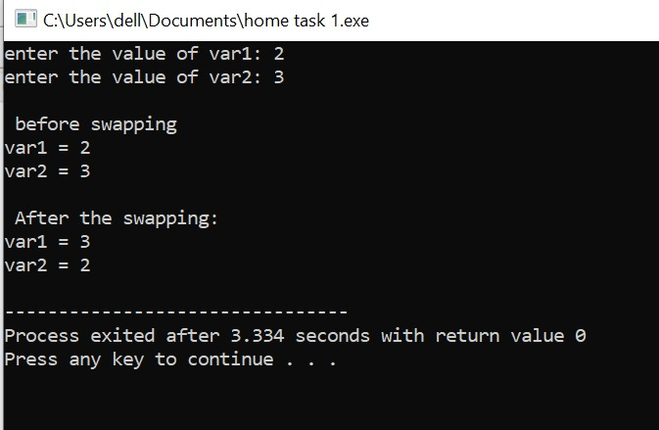
HOME TASK2:
Make upper write a program that prompts the user to enter an alphabet in small caps (a,b,c,…,z) and display the entered alphabet into its upper caps (A,B,C,…,Z).HINT:(ASCII)
#include<iostream>
using namespace std;
int main(){
char letter;
cout<<"enter a small letter: ";
cin>>letter; letter=letter-32;
cout<<"uppercase letter= "<<letter<<endl;
return 0;
}
Output:
enter a small letter: a uppercase letter =A
